What we heard from submissions – Initial Consultation

Purpose
- The purpose of this document is to provide an accessible copy of the slide pack entitled Appendix D: Part 1, What we heard from submissions – Initial Consultation.
- There are 20 slides in the slide pack. Each slide has been converted to provide an accessible copy of the content.

Introduction and Context Section
- Slide 2: This set of slides presents a summary view of the quantitative and qualitative information received by the Hospitality Regulatory Review (the Review) during engagement. It is a summary and synthesis of submitters’ views and opinions and therefore will not fully reflect the views of any one submission, nor has it been fact-checked for the purposes of these slides.
- This summary is not the Ministry for Regulations (the Ministry’s) view on the regulatory systems that affect the hospitality sector. The information received through this engagement process was analysed alongside other evidence to inform the Review’s priorities, findings, and recommendations.

Section One: Who submitted to the Review?
Slide 4: Roles of submitters in the hospitality sector
- Table 1 below provides the number of submitters based on their role in the hospitality sector. The Review received a total of 188 submissions during initial consultation.
Table 1: Number of submitters based on their role in the hospitality sector
Group | Number
Current and former business owners | 87
Current and former hospitality workers | 15
People who work in regulation relevant to hospitality | 54
Organisations who represent hospitality businesses | 20
Other interested parties | 12
TOTAL | 188

Slide 5: Geographical information
- The map below shows the geographical regions of where the submitters were located.
  - 13% of submitters were from Auckland
  - 10% of submitters were from Wellington
  - 8% of submitters were from Canterbury
  - 11% of submitters were from Otago
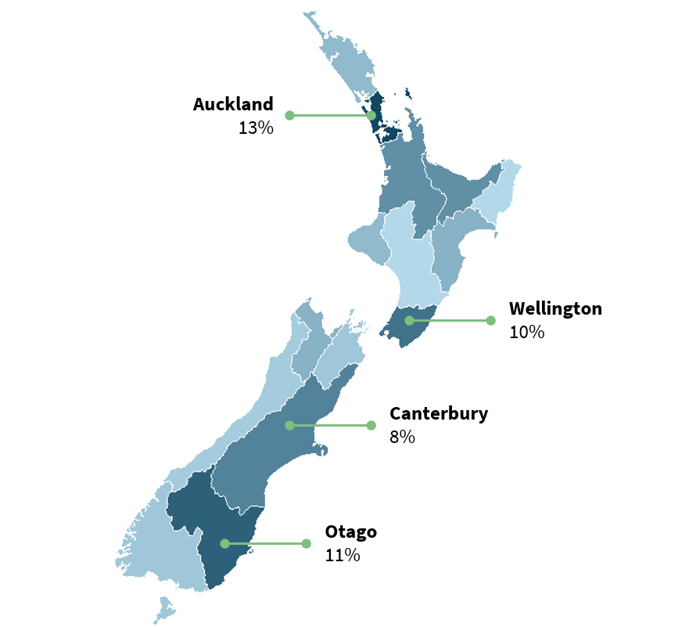
Figure 1: Percent of submitters from geographical regions in New Zealand
- There was an overrepresentation of submissions from Otago (likely from Queenstown) and a slight underrepresentation of submissions from Auckland and Canterbury.
- Twenty-one percent of submitters, on average, work in or cover a rural area, which is slightly more than the 16% of New Zealanders who live in rural areas.

Slide 6: Types of businesses and individual represented.
- We asked submitters what type of businesses they owned, represented, or worked in. Most industry submitters were businesses owners, with most owning restaurants, bars, or cafés.
- We also asked for the length of experience in the hospitality sector hospitality workers and regulators had.
- The highest proportion of hospitality workers had 16+ years of experience, followed by 11 -15 years.
- A similar trend was seen with regulators, with the highest proportion of regulators who submitted having had 16+ years of experience.
- Nearly all submissions from regulators were from those who work for territorial authorities
- The average length of submitters’ experience on one hand provides the Review with confidence they understand the regulatory systems well, but on the other hand they may not have been exposed to other ways of doing things.

Slide 7: Features of the hospitality businesses represented
- Business longevity - 43% of business owners opened a business within the last two years, or are currently opening a business.
- The majority of business owners, own just one business /location, with 71% of business owners run small businesses (with 20 people or less), which is broadly reflective of what we know about the sector.

Section Two: Perceptions of regulatory performance
Slide 9: What are submitters’ overall views?
- The following are themes from submitters overall perceptions of regulatory performance.
- In order of the most common theme:
- Most business want to comply and innovate, but meeting requirements is difficult because the compliance landscape is complicated, fragmented, inconsistent, and resource-intensive
- Many of the requirements are disproportionately burdensome for good operators and may not sufficiently deter poor operators
- Decision-making and enforcement is not sufficiently transparent, nor consistent across time and place
- The requirements and fees are often not sufficiently scaled for business size and risk
- The burden of educating business owners and workers on requirements often falls to front-line regulators
- Some laws are outdated (e.g., trading laws)
And…
- In order of the most common theme:
- Overall, the regulatory systems are effective at protecting public health and reducing harm
- The intentions behind the regulatory systems are correct, but processes could be streamlined to better realise these intentions
- Compliance is an expected cost of doing business
- Representative organisations generally offer effective support to businesses

Slide 10: How easy do regulated parties find it to meet requirements?
Regulated parties’ perceptions of the regulatory systems
- Business owners, workers, and representative organisations were asked to rate, overall, how easy they found it to meet day-to-day regulatory requirements in the hospitality sector:
  - 21% found it very difficult
  - 55% found it difficult
  - 20% found it easy
  - and 4% found it very easy
- Fifty-six percent of owners have accessed government support (mostly from territorial authorities) to understand and or meet the requirements placed on their business but 55% of those who accessed support were dissatisfied or very dissatisfied with that support.

Slide 11: How well do regulators think the systems are working?
Regulated parties’ perceptions of the performance of the regulatory frameworks
- Regulators were asked to rate the performance of the regulatory system(s) they worked in.
- The majority of these submitters regulate food and alcohol, so these assessments are most reflective of the performance of these two regulatory systems.
- Regulators with more experience were slightly less likely to rate the regulatory system as effective.
- Most regulators thought the system(s) they regulated were mostly effective with 74% stating they were mostly effective. Many regulators thought they systems were only partially efficient (33%) and adaptable (31%).

Slide 12: What are the common issues regulators identify?
Regulated parties’ perceptions of regulatory performance
- Overall, business owners and workers not knowing or understanding the requirements. This problem spans all regulatory systems. Regulators indicated that the reasons for this include information about the requirements being inaccessible to business owners, the requirements being unclear, or a lack of education about what underpins the requirements.
- Records not being accurate nor up-to-date. This problem is most prevalent in the food and alcohol regulatory systems. Regulators indicated that the reasons for this include disproportionate record-keeping requirements (which are then not met, or records are falsified to try and meet requirements), language barriers, or business owners and workers not knowing about the requirements.
- Cleanliness, temperature control, pest control, and cross-contamination. These problems are most prevalent in the food regulatory system. Regulators indicated that the reasons for these problems include not knowing or understanding the requirements and ineffective or no training of workers (partly due to worker turnover).

Slide 13: What drives costs for hospitality businesses?
Costs of regulatory compliance. Cost drivers for hospitality businesses.
- Business owners were asked to identify the top factors that drive their cost of operation.
- In order of highest driver of cost:
  - Equipment costs (including subscriptions for software and maintenance)
  - Licensing and inspection costs (for example liquor licensing and food safety inspections)
  - Property costs (including rent or mortgage and utilities)
  - Inventory costs (including food and beverage inventory)
  - Labour costs (including salaries, recruitment, and training)
  - Other types of regulatory compliance costs
  - Other
- Business owners identified licensing and inspection costs as the second highest driver of their costs of operation. Given the nature of the Review, this may be over-represented as regulatory requirements would have been top of mind for submitters when answering this question.
- Sixty-eight percent of submitters raised their prices in the past three years. The most common price increase was between 6 – 10%.
- Key issues raised, in order, were:
  - general economic environment
  - increase in certification, registration, or licencing costs
  - increase in other fees or levies (for example, council rates)
  - increase in labour costs.

Slide 14: What are the barriers businesses face?
Barriers to market entry, expansion, and innovation. Opening a business.
- Business owners were asked to rate how easy they found it to access the information required to start a business, and how easy it was to meet the requirements.
- Access to information:
  - 16% found it very difficult
  - 43% found it difficult
  - 35% found it easy
- Ease of meeting the requirements:
  - 21% found it very difficult
  - 51% found it difficult
  - 20% found it easy
  - And 8% found it very easy
- Sixty percent of business owners identified they were prevented from innovating or meeting a demand.
- Key issues raised, in order, were:
  - Demand to expand the business, but prevented from doing so due to costs (including inspection costs) or inability to hire staff
  - Demand to expand to different types of service (e.g., wholesale food, or selling alcohol), but prevented from doing so due to unclear regulation or regulatory barriers (e.g., an activity is not permitted in their situation)
- Thirty-two percent of business owners who submitted had closed a business, which is higher than the average closure rate of hospitality firms in New Zealand.
- Key issues raised, in order, were:
  - general economic environment, including the economic effects of the COVID pandemic
  - increase in labour costs
  - compliance requirements causing delays in opening (including objections to alcohol licences), and therefore financial losses.

Section Three: What should change
Slide 16: Where do regulated parties think change is needed?
Regulated parties’ perceptions of the regulatory systems.
- Overall are changes needed to the regulatory requirements? Submitters were asked to rate each regulatory system as “Need major changes”, “Need minor changes”, or “Work well”.
- In order of those areas that need the most change…
  - Sale and supply of alcohol
  - Employment
  - Food safety
- In order of those that work well…
  - Consumer protection
  - Transport
  - Health and Safety
  - Building

Slide 17: Why do regulated parties think change is needed?
Regulated parties’ perceptions of the regulatory systems.
- Why do submitters want to change regulatory requirements? Business owners, workers, and representative organisations were asked to identify if they think changes are needed, and if so, why those changes were needed. Submitters could choose multiple reasons. In order of the most prevalent reasons:
  - 76% thought it costs too much money to comply with the requirements
  - 66% thought it takes too much time to comply with the requirements
  - 51% thought the requirements are not enforced consistently
  - 51% thought the requirements don’t make sense for my situation
  - 42% thought the requirements are difficult to understand
  - 25% thought the penalty for breaching the requirements is too high
  - 22% thought the requirements are enforced too strictly
  - 21% thought the requirements are not specific or strong enough
  - 9% chose other reasons
  - 5% thought the requirements are not enforced at all

Slide 18: What are the gaps, duplications, and inconsistencies?
Submitters’ views on the overlaps between regulatory systems
- Thirty-five percent of business owners think there are gaps in the regulatory systems. The most commonly identified gaps are lack of oversight of inconsistent and disproportionate decisions, and disregarding experience and previous good behaviour.
- Seventy-six percent of regulators think there are gaps in the regulatory systems. The most commonly identified gaps are graduated enforcement tools for enforcement of food safety requirements and the inability to identify unregistered businesses.
- Fifty-eight percent of submitters think there is duplication in the regulatory systems. The most commonly identified duplications are between local food inspectors and MPI, and more broadly between central and local government.
Slide 19: What should change?
Submitters’ views on what should change.
- The following are submitters recommendations on what should change across multiple regulatory systems. Specific recommendations needed to be made at least 3 times across submissions before being included here.
- In order of the most common theme:
  - Streamline application, registration, renewal, and verification processes across all regulatory systems to reduce paperwork requirements and avoid supplying the same information to multiple regulators. Some submitters suggested introducing a single online portal for all compliance activities
  - Provide consolidated guidance that clearly outlines the end-to-end process of starting up and running a hospitality business
  - Improve the quality, transparency and consistency of regulators’ decisions
  - Clarify or remove ANZAC / Easter / Christmas trading restrictions
  - Lower fees and or levies, or scale them to the size and risk of the business
  - Require education on relevant requirements before the registration of a business
  - Introduce statutory timeframes for certain decisions to give businesses certainty

Slide 20: What should change?
Submitters’ views on what should change.
- The following are submitters recommendations on what should change within a single regulatory system. Specific recommendations needed to be made at least 3 times across submissions before being included here.
- In order of the most common theme:
  - Introduce a more flexible, risk-based licensing system for alcohol to support good, low-risk operators and free up regulatory resource to focus on higher-risk operators
  - Raise the thresholds for when building and resource consents are required for routine, low-risk activities (e.g., marquees, dining outside)
  - Reverse announced policy changes around card surcharges
  - Reduce excise tax on alcohol drunk on licenced premises (e.g., kegged beer)
  - Introduce more infringement offences in the alcohol regulatory system
  - Allow for more exemptions and / or flexibility in Food Control Plans for low-risk food businesses
  - Allow workers on Accredited Employer Work Visas to be re-deployed across sites run by the same hotel chain
  - Introduce more graduated enforcement tools for the enforcement of food safety requirements
  - Reduce barriers for regulators to assess low-risk food businesses (e.g., NP1)

[ENDS]

