HOW TO USE THE COST RECOVERY ANALYSIS SUMMARY (CRAS) TEMPLATE
This CRAS template replaces the previous Cost Recovery Impact Statement 2 (CRIS 2) template. Use this template for proposals seeking agreement on cost recovery levels.
Note that this CRAS template will be updated following the implementation of the Regulatory Standards Act 2025. Please check the Ministry for Regulation website for the most up-to-date template.
d to inform Ministers’ policy decisions at Cabinet.


While the CRAS template includes principles in the Regulatory Standards Act and will provide input to the Consistency Accountability Statement (CAS), it is consistent with the current impact analysis framework. The prompts in the template are intended to be used as a guide - some will be more applicable than others depending on the nature of the proposal.

There is a strong expectation that this summary document is no longer than twenty pages. Where a proposal is complex or multi-part, please review the Ministry for Regulation impact analysis guidance on how best to approach the structure of the analysis.

Confirm Quality Assurance arrangements on RIA Online
Ensure that your proposal has an entry on RIA Online, and complete the “Process Confirmation” tab to confirm QA arrangements and template. This also generates your Ministry for Regulation identification number for your Cabinet paper. Instructions are available on the Ministry for Regulation’s website – Meeting regulatory impact requirements.

- See below for cost recovery guidance:
- Treasury Guide: Guidelines for Setting Charges in the Public Sector
- Controller and Auditor-General Guide: Charging fees for public sector goods and services


Cost Recovery Analysis Summary: [Proposal title]
Decision sought | [e.g., in principle Cabinet decisions, final Cabinet policy decisions to introduce/change regulation on X topic]
Agency responsible
Portfolio Minister(s)
Date finalised
Ministry for Regulation identification number |  | [This number will be provided though RIA Online and be in the format of “REG-XXXX”.]

The boxes below are intended to be a brief summary. The coversheet should be no longer than 2-3 pages.

Summary of recommended cost recovery proposal

Have any potential inconsistencies with the principles of responsible regulation in the Regulatory Standards Act been identified with the cost recovery proposal, including sections 9(d)-(f) relating to taxes, fees, and levies?
Yes / no
[if yes, specify which principle(s)]

Limitations and constraints on analysis
Condensed timeframes | [Yes, No] | Constrained option set | [Yes, No]
Legislative constraints | [Yes, No] | Data and evidence gaps | [Yes, No]
Ministerial direction | [Yes, No] | Other | [Yes, No]
Limited public consultation | [Yes, No]
Summary of limitations and constraints on analysis

What are the implications of these limitations and constraints, and what has been done – or will be done – to mitigate and manage them?

I am satisfied that, given the available evidence, this CRAS represents a reasonable view of the impacts and analysis of the recommended cost recovery proposal.
Responsible Manager(s) signature:
[Insert Manager’s name]
[Insert Manager’s title]
[Insert date]

Quality Assurance Statement
Reviewing [Agency/Agencies]: | QA rating: [Meets, partially meets, does not meet]
Panel Comment:

Section 1: Status quo
- [enter text here – use the ‘Numbered paragraph’ style]
Guidance for this section
- A description of the activity and why it is undertaken.
- What policy outcomes will the activity achieve?
- What is the rationale for government intervention?
- What relevant policy decisions have been made? Substantial detail is not required here, but a clear explanation of what has been agreed to and what has not been agreed to is needed.
- The statutory authority to charge ie, the Act that gives the power to cost recover.
- Is this a new or amended fee?
- If this proposal is a review of existing charges then the following questions need to be addressed:
- What is the reason for the review? eg, scheduled review or addressing a problem with current user charge levels
- Describe the existing cost recovery policy eg, what activities does it cover?
- Where is the current schedule of charges located (i.e. the current fees and levies that are currently in place)?
- Identify the problem(s) with carrying on under the status quo.

Section 2: Cost recovery principles and objectives
- [enter text here – use the ‘Numbered paragraph’ style]
Guidance for this section
See section 1.3 “Key considerations in cost recovery” in the Treasury’s ‘Guidelines for Setting Charges in the Public Sector’ for more information.
- What are the underlying principles that apply to and guide the cost recovery proposal? These principles should come from the Act that gives authority to cost recover and the OAG guidelines. A feasible option must meet the stated principles.
  - The principles can be stated with a brief description of each provided. For example:
  - Authority: A public entity must have legal authority to charge a fee and must operate within the scope of the empowering provision.
- Efficiency: The user charge should be no higher than necessary to produce a good or service to the desired level of quality. The design of the charge should incentivise efficiency ie, keeping costs down and the quality of the service high.
- What are the objectives of the cost recovery proposal? These objectives should be a combination of the Cost Recovery principles, the intent of the policy that is being cost recovered and the objectives in the Treasury guidance. For example:
  - Equity (also described as fairness): The user charge is being paid by the appropriate people. Thought will have to be given to whether the risk exacerbator and/or the beneficiary pays for the good or service.
  - Maintain desired level of safety. The user charge needs to be at a level that will allow the regulator to fully carry out their functions and not undermine the safety of the regime (particularly relevant for safety inspection practices).
- The objectives will be used to assess the selected option for effectiveness in the future.

Section 3: Policy rationale – why a user charge? And what type is most appropriate?
- [enter text here – use the ‘Numbered paragraph’ style]

Guidance for this section

See section 3 “The policy rationale for cost recovery” in the Treasury’s ‘Guidelines for Setting Charges in the Public Sector’ for more information.

- Why is cost recovery appropriate for the activity (over and above the legal authority to charge) ie, why should it be third party funded rather than funded by the Crown?
- What is the nature of output from the activity (the characteristics of the good or service) eg, public/private/club goods (see section 3.2 of Treasury guidelines)?
- Is full or partial cost recovery being proposed? What is the rationale for proposing full or partial cost recovery?
- What type of charge is being proposed eg, fee, levy, hourly charge? What is the rationale behind selecting this type of charge?
- Who will pay the cost recovery charges? Include data on the number and size of businesses, individuals etc, if possible.
- Assessment of proposed user charge against objectives.

Section 4: The level of the proposed fee and its cost components (cost recovery model)
- [enter text here – use the ‘Numbered paragraph’ style]

Guidance for this section

- See section 5 “Bringing it all together - Design of cost recovery” in the Treasury’s ‘Guidelines for Setting Charges in the Public Sector’ for more information.
- Design of cost recovery charges. What are the proposed charge levels? If this is a review, compare them to the current levels and have a column with the percentage change.
- Outputs and processes of the activity. What are the main cost drivers of the activity? ie, what are the outputs of the activity and the business processes that are used to produce those outputs? This should be itemised and explained in a table or similar method (see figure 1.1 and figure 1.2 in annex for example).
- Costing the activity. Breakdown of the user charge, for example: direct costs eg, staff salaries (including on-costs, such as training, superannuation and leave) and indirect costs eg, salaries of staff in corporate roles such as finance and human resources, (see figure 1.3 in annex for example).
- Present forecast total revenue, ideally over the first three year (see figure 1.4 in annex for example). If this is a review existing revenue information should also be provided.
- Present estimates of expenses and revenue for the activity. The estimates should illustrate the potential for revenue and expenses to align.
- Discuss how changes in the underlying assumptions will affect financial estimates.
- If this proposal is a review and an increase in user charges is proposed, is pursuing options for efficiency/productivity improvements, or making changes to levels of expected service delivery, or vary the expected memorandum account balance, without any change in fee levels a feasible option?

Section 5: Impact Analysis
- [enter text here – use the ‘Numbered paragraph’ style]
Refer to the principles in section 9 of the Regulatory Standards Act, including sections 9(d)-(f) relating to taxes, fees, and levies.

Guidance for this section

See section 3.4 “Impacts and incentives in cost recovery regimes” in the Treasury’s ‘Guidelines for Setting Charges in the Public Sector’ for more information.

- What is the impact of the proposed fee? How many people, businesses etc. will be effected? What is the change in cost they will face?
- Impacts/risks on the regulator eg, service performance risks.
- Expected effects on demand for services.
- What is the evidence that the cost recovery arrangements are reasonable? Eg, comparison to privately provided services or an international comparison if feasible (see figure 1.5 in annex for example).
- Have any potential inconsistencies with the principles of responsible regulation in the Regulatory Standards Act been identified with the cost recovery proposal, including sections 9(d)-(f) relating to taxes, fees, and levies?

For more information on the taxes, fees and levies principles, refer to Guidance issued under section 26 of the Regulatory Standards Act 2025.
Section 6: Consultation
- [enter text here – use the ‘Numbered paragraph’ style]

Guidance for this section

See section 2.5 “Consultation approach” of the Treasury’s Regulatory Impact Analysis handbook for more information.

- Explain who has been consulted, what form the consultation took and what options were canvassed.
- Outline key feedback received, with particular emphasis on any significant concerns that were raised about the preferred option and how the proposal has been altered to address these concerns (or if not, why not).
- If there was limited or no consultation undertaken, the reasons why should be explained.

Section 7: Conclusions and recommendations
- [enter text here – use the ‘Numbered paragraph’ style]

Guidance for this section

- Summarise and present the cost recovery proposal.
- It is not mandatory for an agency to recommend or reject a particular option. But where an agency does so, it should explain and justify their recommendation in the RIS.

Section 8: Implementation plan
- [enter text here – use the ‘Numbered paragraph’ style]

Guidance for this section

See section 6 “Implementation, monitoring and managing cost recovery regimes” in the Treasury’s ‘Guidelines for Setting Charges in the Public Sector’ for more information.

- Summarise how the proposed option(s) will be given effect, including transitional arrangements.
- Describe how implementation risks will be being mitigated.
- Describe the steps that are being taken to minimise compliance costs.
- Describe how the proposal would interact with, or impact on, existing regulation, including whether there is scope to reduce or remove any existing regulations.
- Outline the enforcement strategy that will be implemented to ensure that the preferred option achieves its public policy objectives.

Section 9: Monitoring and evaluation
- [enter text here – use the ‘Numbered paragraph’ style]

Guidance for this section

See section 6 “Implementation, monitoring and managing cost recovery regimes” in the Treasury’s ‘Guidelines for Setting Charges in the Public Sector’ for more information.

- Outline plans for monitoring, benchmarking and evaluating the effectiveness of the preferred option, including performance indicators and how the necessary data will be collected.
- What performance metrics will be established to assess the performance of the regulator? This is important to prove that activities are operating efficiently and meet the ‘open book’ approach to cost recovery. For example:
  - Require x% of all applications for licences to be completed within x working days.
  - Notifications are provided when the service or good is not going to be provided by the proposed time.
  - For variable charges: an indication of expected cost, how this relates to the average, and if it is different what is the reason.
- Having performance metrics in place is particularly important for variable charges eg hourly fees.

Section 10: Review
- [enter text here – use the ‘Numbered paragraph’ style]

Guidance for this section

See section 6.7 “Reviews of cost recovery regimes” in the Treasury’s ‘Guidelines for Setting Charges in the Public Sector’ for more information.

- The expectation is that cost recovery regimes are reviewed at least every three years. Explain how and when it will be reviewed and what the review process will involve (and if no plans for review, the reasons why). This might be as simple as updating this template.

Annex 1: Best practice examples
Figure 1.1: The cost drivers of an activity, broken down by outputs and business processes
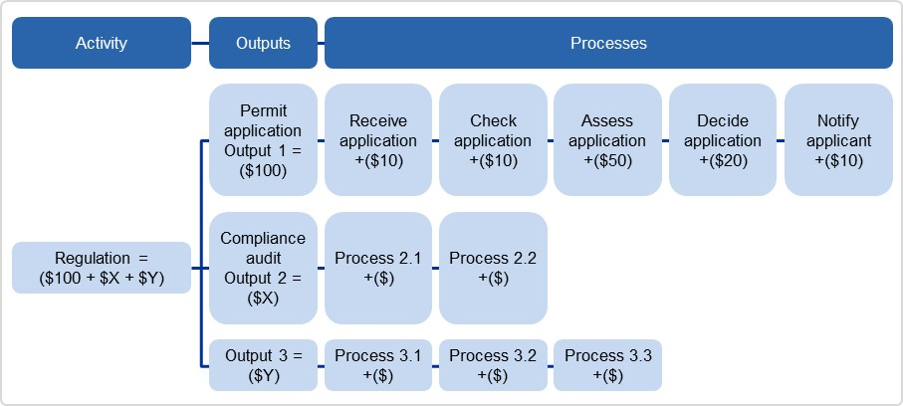
Source: Australian Government Cost Recovery Guidelines, Pg. 33. http://www.finance.gov.au/sites/default/files/australian-government-cost-recovery-guidelines.pdf

Figure 1.2: Breakdown of User Charge Example: Proposed 10-year adult e-passport fee breakdown
Source: Passport Canada Fee-for-Service Proposal, Pg. 20
Figure 1.3: Allocating and apportioning costs to a cost object (eg, an output)
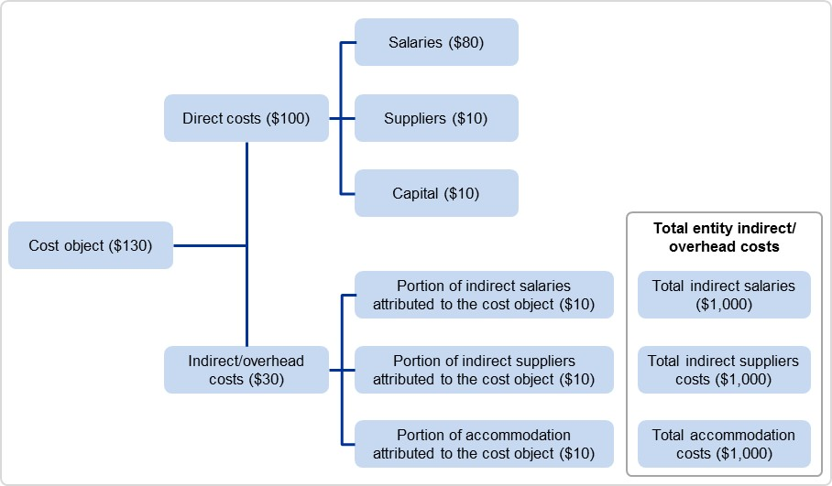
Activity
Source: Australian Government Cost Recovery Guidelines, Pg. 36. http://www.finance.gov.au/sites/default/files/australian-government-cost-recovery-guidelines.pdf

Figure 1.4: Forecast fee revenue example (2014/15)
Application | Fees ($) | No. of Applications | Revenue  ($000)
Initial Provider Registration | $22,000 & $85,000 | 18 | 396
Renewal of Provider Registration | $20,000 & $75,000 | 38 | 1,310
Initial Course Accreditation | $9,000 (1st course/app.),  $6,300 (2nd course+/app.) | 157 | 1,151
Renewal of Course Accreditation | $8,000 (1st course/app.),  $5,600 (2nd course+/app.),  $1,000 (teach out) | 207 | 1,231
CRICOS Registration | $5,000 | 2 | 10
CRICOS Re-Registration | $5,000 | 25 | 125
Other CRICOS Matters | $2,500 for 2 specific changes | 28 | 70
Self-Accreditation Authority Fee | Partial SAA ($0 & $10,000),  Full ($0 & $22,000) | 4 | 88
Application | Fees ($) | No. of Applications | Revenue  ($000)
Initial Provider Registration | $22,000 & $85,000 | 18 | 396
Renewal of Provider Registration | $20,000 & $75,000 | 38 | 1,310
Initial Course Accreditation | $9,000 (1st course/app.),  $6,300 (2nd course+/app.) | 157 | 1,151
Renewal of Course Accreditation | $8,000 (1st course/app.),  $5,600 (2nd course+/app.),  $1,000 (teach out) | 207 | 1,231
CRICOS Registration | $5,000 | 2 | 10
CRICOS Re-Registration | $5,000 | 25 | 125
Other CRICOS Matters | $2,500 for 2 specific changes | 28 | 70
Self-Accreditation Authority Fee | Partial SAA ($0 & $10,000),  Full ($0 & $22,000) | 4 | 88
TOTAL |  | 479 | 4,381
Source: Tertiary Education Quality and Standards Agency Cost Recovery Implementation Statement, Pg.12
Figure 1.5: Comparison of international passport fees
Service | United Kingdom | United States | New Zealand | Australia | Canada (proposed)
Service | Fee comparison
Validity period | 10 years | 10 years | 5 years | 10 years | 10 and 5 years
ePassport | Yes | Yes | Yes | Yes | Yes
Regular adult fee | £77.50  ($122) | US$135  ($139) | NZ$153.30 ($120) | AU$233  ($238) | 10-year: $160 5-year: $120
Children's fees (approximate % of cost of adult passport) | £49 (63%) ($77) | US$105 (78%)  ($108) | NZ$80.70 (53%)  ($64) | AU$117 (50%)  ($119) | $57 (60%)
Fee per year of validity | £7.75  ($12) | US$13.50 ($14) | NZ$30.66  ($24) | AU$23.30  ($24) | 10-year: $16  5-year: $24
Source

Examples of problems with current user charges which means change is required: better management of memorandum account, changes in input prices, changes in level of demand, service composition change, desire for better service performance.

