HOW TO USE THE STAGE 1 COST RECOVERY ANALYSIS SUMMARY (CRAS 1) TEMPLATE
The stage 1 Cost Recovery Analysis Summary (CRAS1) template replaces the previous Cost Recovery Impact Statement (CRIS1) template and is required to inform Ministers’ policy decisions at Cabinet.

Note that this CRAS template will be updated following the implementation of the Regulatory Standards Act 2025. Please check the Ministry for Regulation website for the most up-to-date template.

The CRAS1 template is designed specifically for proposals seeking policy agreement to cost recover but not yet seeking policy agreement on cost recovery levels (ie, agreement on cost recovery levels will be sought at a later date).

Depending on the nature of Cabinet decisions which are being made, the stage 1 template could either be a standalone document or complement a Regulatory Analysis Summary (RAS) which is supporting wider policy decisions on legislation.

The purpose of the CRAS1 template is to provide a place to clearly explain the policy rationale for cost recovery and to provide a high-level cost recovery model, which includes estimates of the cost recovery levels. In other word, the CRAS1 should set out analysis showing why cost recovery is appropriate. The RAS is the document that contains the analysis on the proposal that cost recovery is being sought for.

There is a strong expectation that this summary document is no longer than twenty pages. Where a proposal is complex or multi-part, we have provided guidance on how best to approach the structure of the analysis (see links in the template).

How to obtain a Ministry for Regulation tracking number
The Ministry for Regulation identification (ID) number can be obtained through RIA Online. Instructions for accessing RIA Online are available on the Ministry for Regulation’s website.


Stage 1 Cost Recovery Analysis Summary: [Proposal title]
Decision sought | [e.g., Cabinet decisions to cost recover a certain function (without getting agreement to specific cost recovery levels)]
Agency responsible
Portfolio Minister(s)
Date finalised
Ministry for Regulation ID number |  | [This number will be provided though RIA Online and be in the format of “REG-XXXX”.]

The boxes below are intended to be a brief summary. The coversheet should be no longer than 2-3 pages.

Brief description of the Minister’s cost recovery proposal (preferred option)

Have any potential inconsistencies with the principles of responsible regulation in the Regulatory Standards Act been identified with the cost recovery proposal, including sections 9(d)-(f) relating to taxes, fees, and levies?
Yes / no
[if yes, specify which principle(s)]

Limitations and constraints on analysis
Condensed timeframes | [Yes, No] | Constrained option set | [Yes, No]
Legislative constraints | [Yes, No] | Data and evidence gaps | [Yes, No]
Ministerial direction | [Yes, No] | Other | [Yes, No]
Limited public consultation | [Yes, No]
Summary of limitations and constraints on analysis

What are the implications of these limitations and constraints, and what has been done – or will be done – to mitigate and manage them?

I am satisfied that, given the available evidence, this CRAS represents a reasonable view of the likely costs, benefits and impact of the preferred option.
Responsible Manager(s) signature:
[Insert Manager’s name]
[Insert Manager’s title]
[Insert date]

Quality Assurance Statement
Reviewing [Agency/Agencies]: | QA rating: [Meets, partially meets, does not meet]
Panel Comment:

Section 1: Status Quo
What is the status quo?

- [enter text here – use the ‘Numbered paragraph’ style]

Guidance for defining the status quo
Describe the activity and why it is undertaken

What policy outcomes will the activity achieve?
What is the rationale for government intervention?
What are the relevant policy decisions that have been made?
- Substantial detail is not required here, but a clear explanation of what has been agreed and what has not been agreed to is needed.

What is the statutory authority to charge?
i.e., the Act that gives the power to cost recover

Is this a new or amended fee?

Section 2: Policy Rationale
Why a user charge? And what type is most appropriate?

- [enter text here – use the ‘Numbered paragraph’ style]

Guidance for Policy Rationale
Why is cost recovery appropriate for the activity?
Over and above the legal authority to charge. i.e., why should it be third party funded rather than funded by the Crown?

What is the nature of output from the activity?
The characteristics of the good or service. E.g., public/private/club goods (see section 3.2 of Treasury guidelines)

Is full or partial cost recovery being proposed?
- What is the rationale for proposing full or partial cost recovery?

What type of charge is being proposed?
E.g., fee, levy, hourly charge
- What is the rationale behind selecting this type of charge?

Who will pay the cost recovery charges?
Include data om the number and size of businesses, individuals etc, if possible.

Section 3: High level cost recovery model (the level of the proposed fee and its cost components)
What is the high-level cost recovery model?

- [enter text here – use the ‘Numbered paragraph’ style]

Guidance for high level cost recovery model
What are the estimated charges?
At stage 1 it is unlikely levels are known with 100 percent confidence, if this is the case ensure that any assumptions are made explicit.

What are the main cost drivers of the activity?
- What are the outputs of the activity and the business processes that are used to produce those outputs?
This should be itemised and explained in a table or similar method (see figure 1.1 and figure 1.2 in annex for example).

Breakdown of the user charge
Example: direct costs eg, staff salaries (including on-costs, such as training, superannuation and leave) and indirect costs eg, salaries of staff in corporate roles such as finance and human resources (see figure 1.3 in annex for example)

Present estimates of expenses and revenue for the activity.
The estimates should illustrate the potential for revenue and expenses to align.

Discuss how changes in the underlying assumptions will affect financial estimates

Section 4: Consultation
- [enter text here – use the ‘Numbered paragraph’ style]

Guidance for consultation
Explain who has been consulted (or who will be consulted), what form the consultation took and what options were canvassed.

Outline key feedback received, with particular emphasis on any significant concerns that were raised about the preferred option and how the proposal has been altered to address these concerns (or if not, why not).

Explain how consultation will be managed for the rest of the process (that is, while the detailed cost recovery model is developed, and through implementation).

Annex 1: Best practice examples
Figure 1.1: The cost drivers of an activity, broken down by outputs and business processes
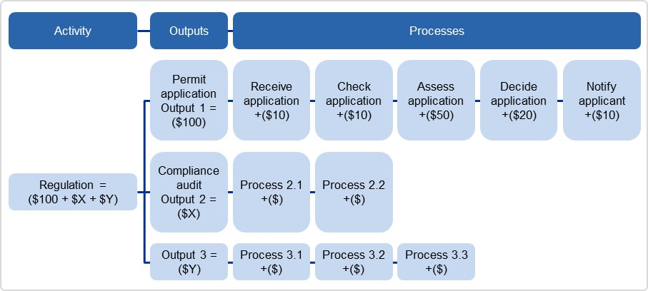
Source: Australian Government Cost Recovery Guidelines, Pg. 32.
Figure 1.2: Breakdown of User Charge Example: Proposed 10-year adult e-passport fee breakdown

Figure 1.3: Allocating and apportioning costs to a cost object (eg, an output)
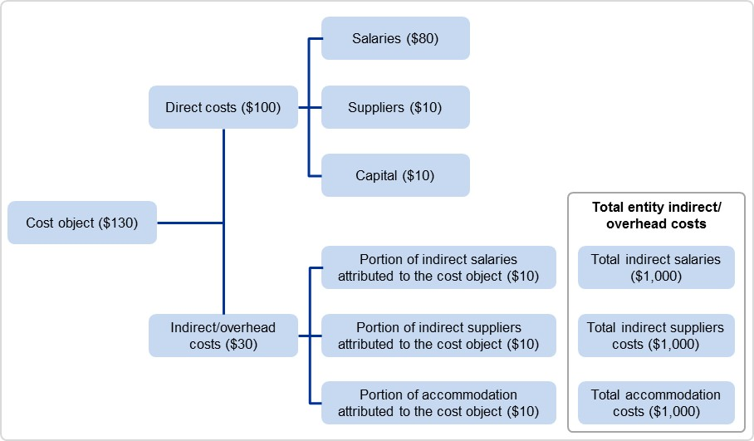
Source: Australian Government Cost Recovery Guidelines, Pg. 32.

